Experiment -1
Create numeric, character, and logical vectors and display type and content.
R-Code:
# Numeric vector
a <- c(10, 20, 30, 40, 50)
print(a)
print(paste("Type:", class(a)))

# Character vector
b <- c("Apple", "Banana", "Mango", "Orange")
print(b)
print(paste("Type:", class(b)))

# Logical vector
c <- c(TRUE, FALSE, TRUE, FALSE)
print(c)
print(paste("Type:", class(c)))
Output:
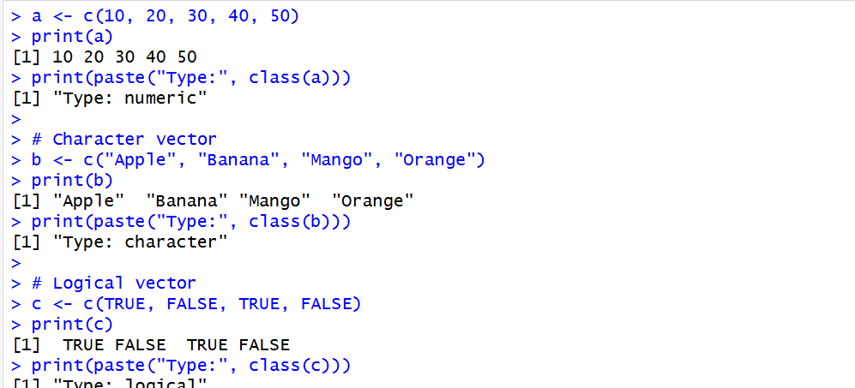

Experiment-2
Create labeled matrices (5×4, 3×3, 2×2) filled by row/column.
R-Code:
a <- matrix(1:20, 5, 4, byrow=TRUE)
rownames(a) <- c("R1","R2","R3","R4","R5")
colnames(a) <- c("C1","C2","C3","C4")
a

b <- matrix(1:9, 3, 3)
rownames(b) <- c("R1","R2","R3")
colnames(b) <- c("C1","C2","C3")
b

c <- matrix(1:4, 2, 2, byrow=TRUE)
rownames(c) <- c("R1","R2")
colnames(c) <- c("C1","C2")
c
Output:

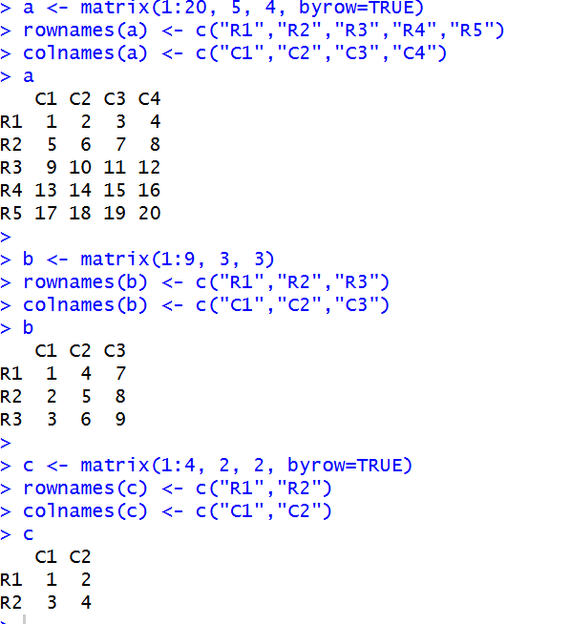
Experiment-3
Write an R program to create and display a 3D array with specified rows, columns, and tables.
R-Code:
a <- array(1:24, dim=c(3,4,2))

dimnames(a) <- list(
c("R1","R2","R3"),
c("C1","C2","C3","C4"),
c("T1","T2")
)

a
Output:
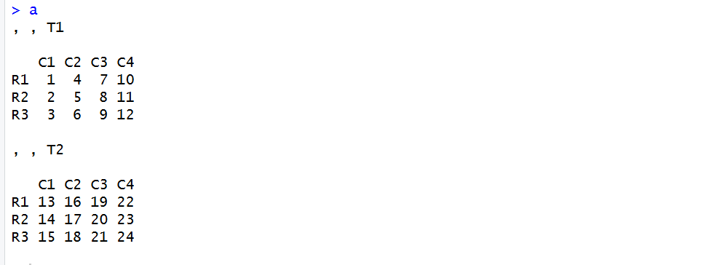
Experiment-4
Create arrays from vectors with dimension names, print specific elements.
R-code:
a <- 1:12

b <- array(a, dim=c(2,3,2))

dimnames(b) <- list(
c("R1","R2"),
c("C1","C2","C3"),
c("T1","T2")
)

b

b[1,2,1]
b[2,3,2]

Output:
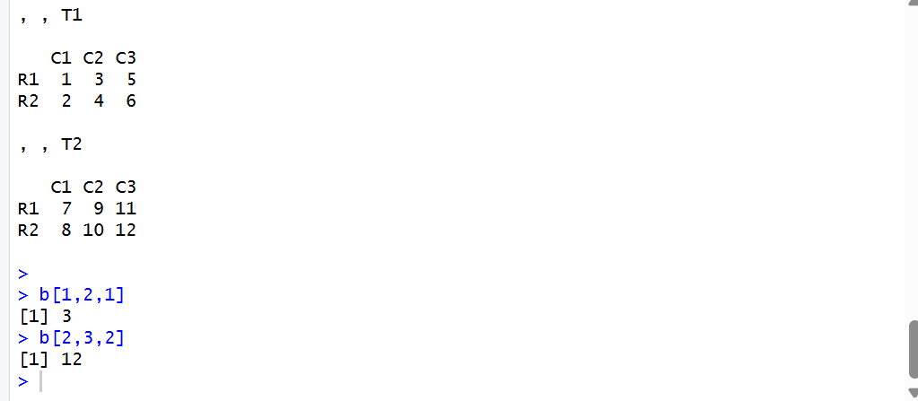
Experiment-5
Create and manipulate factor variables (e.g., women’s dataset heights, random LETTERS sample).
R-Code:
a <- c("Short", "Medium", "Tall", "Medium", "Tall", "Short")

b <- factor(a)
print(b)

set.seed(10)

c <- sample(LETTERS[1:5], 8, replace = TRUE)

d <- factor(c)
print(d)
Output:
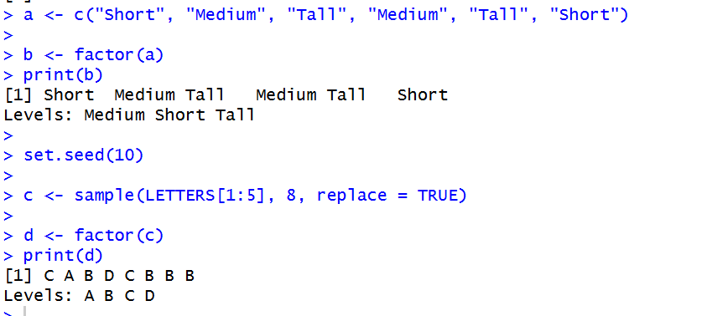

Experiment-6
Create an R list containing vectors, matrices, and functions; display contents.
R-Code:
v <- c(10, 20, 30)

m <- matrix(1:4, 2, 2)

f <- function(x) {
x * 2
}
mylist <- list(Vector = v, Matrix = m, Function = f)

print(mylist)
Output:
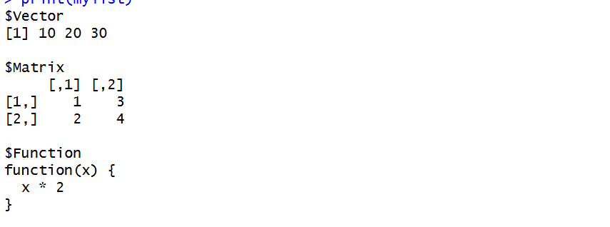
Experiment-7

R-Code:
# A. Factors of a number
n <- 12

for(i in 1:n) {
if(n %% i == 0)
print(i)
}

# B. Random integers
set.seed(10)
x <- sample(-50:50, 10)
print(x)

# C. FizzBuzz
for(i in 1:100) {
if(i %% 15 == 0)
print("FizzBuzz")
else if(i %% 3 == 0)
print("Fizz")
else if(i %% 5 == 0)
print("Buzz")
else
print(i)
}
Output:
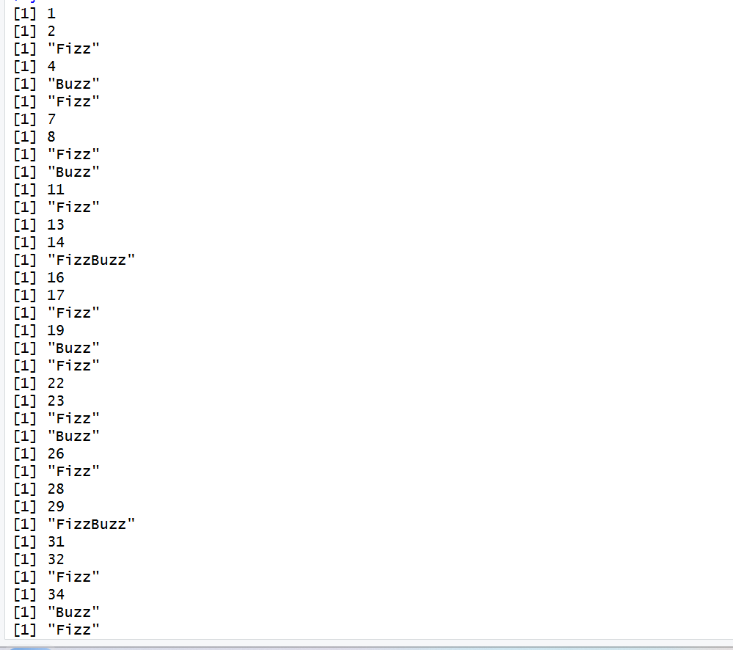

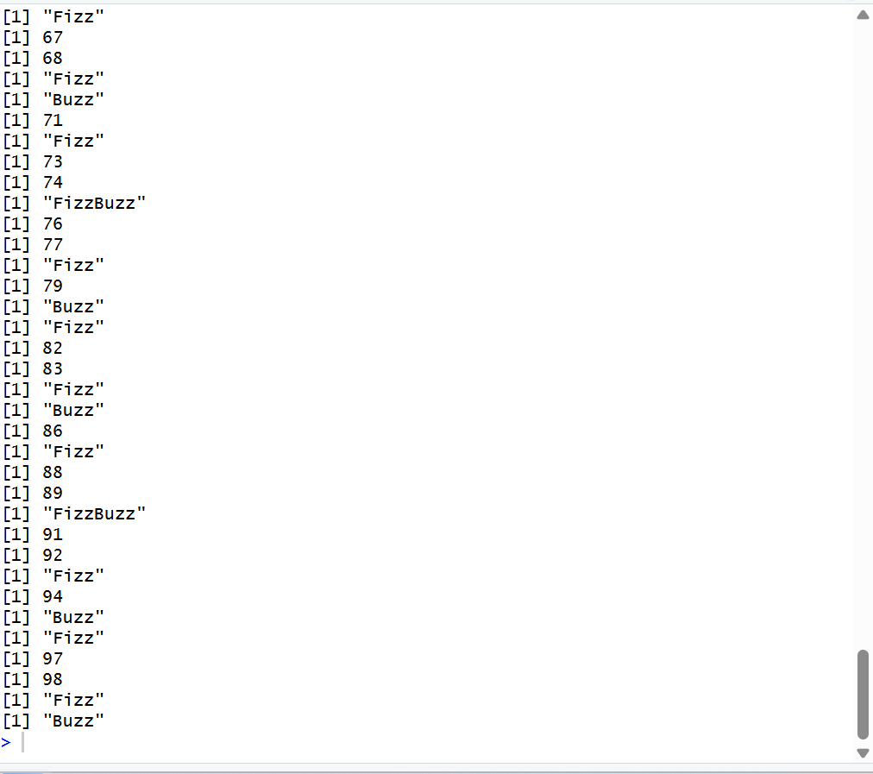

Experiment-8
Generate random numbers from a normal distribution; count occurrences.
R-Code:
set.seed(123)
x <- rnorm(100)
y <- table(round(x))
print(as.data.frame(y))
Output:
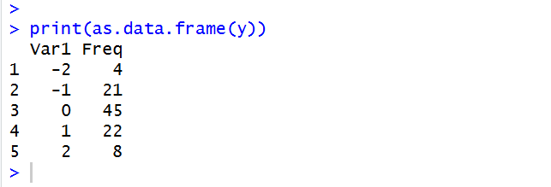

Experiment-9
Create empty plots with specified axis limits.
R-Code:
plot(0, 0,
xlim = c(0, 10),
ylim = c(0, 10),
type = "n",
xlab = "X Axis",
ylab = "Y Axis",
main = "Empty Plot")
Output:
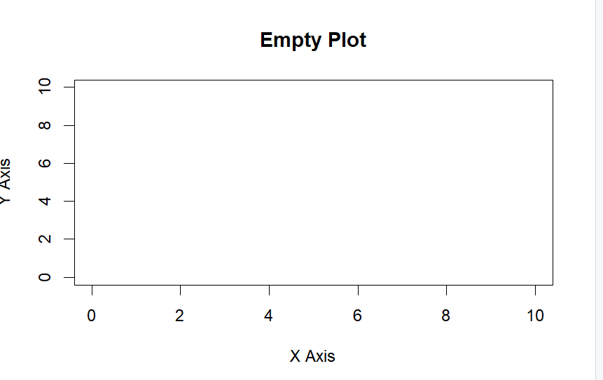

Experiment-10
Create and explore a data frame exam_data with name, score, attempts, and qualifying fields. Perform extract, add row/column, sort, save to file.
R-Code:
name <- c("John", "Sara", "David", "Priya")
score <- c(85, 72, 90, 65)
attempts <- c(1, 2, 1, 3)
qualifying <- c(TRUE, TRUE, TRUE, FALSE)

exam_data <- data.frame(name, score, attempts, qualifying)

# Display data
print(exam_data)

# Extract data
print(exam_data[1, ])
print(exam_data[, "score"])

# Add a column
exam_data$Grade <- c("A", "B", "A", "C")

# Add a row
exam_data <- rbind(exam_data,
data.frame(name = "Arun",
score = 78,
attempts = 2,
qualifying = TRUE,
Grade = "B"))

# Sort by score
exam_data <- exam_data[order(exam_data$score), ]

print(exam_data)

# Save to CSV file
write.csv(exam_data, "exam_data.csv", row.names = FALSE)

Output:
